Project Design Phase-l

AI FAQ Assistant – Idea & Feature Prioritization

Date | 21-09-2026
Team ID | SWTID-2026-1780
Project Name | AI Frequently Asked Questions
Maximum Marks | 4 Marks

AI FAQ flow diagram
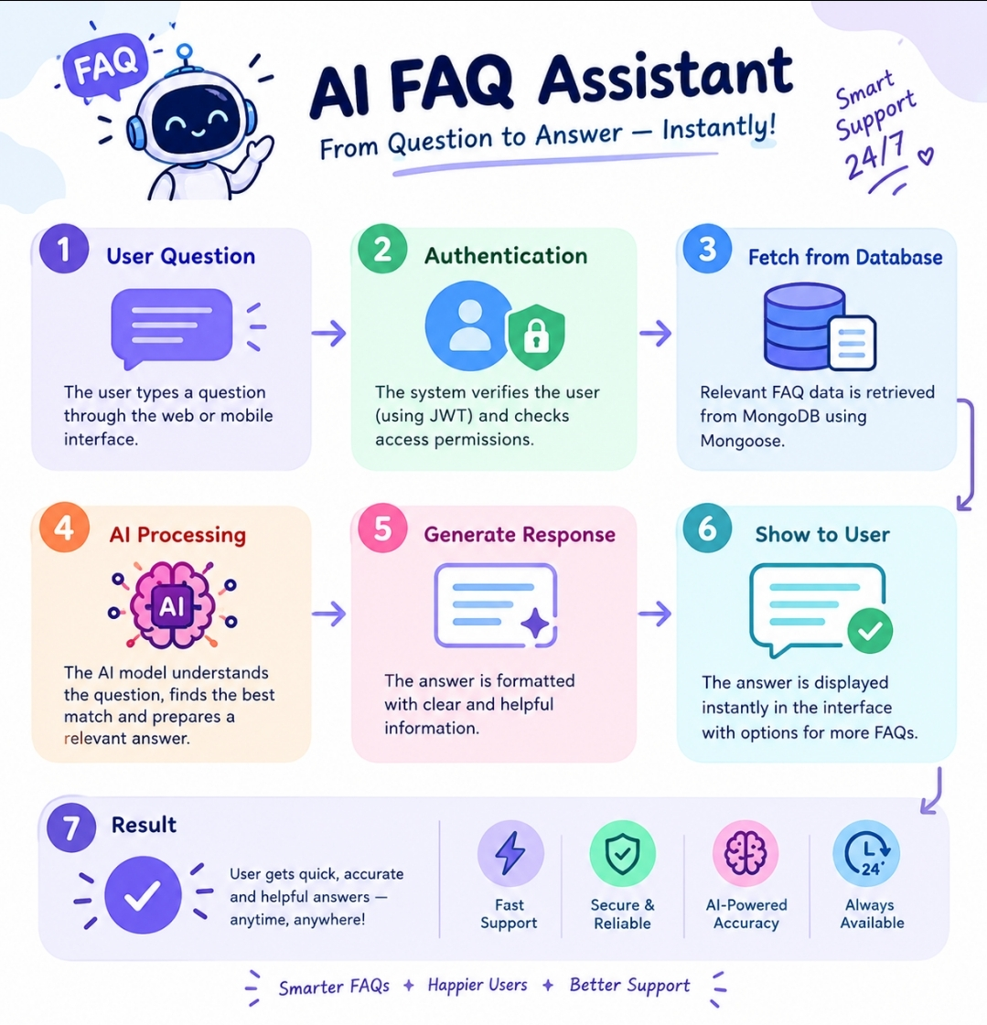

1. Introduction
AI FAQ Assistant is an AI-powered application designed to provide quick and accurate answers to frequently asked questions. It helps users find information easily without manually searching through large amounts of content.

- Steps | - Topic | - Definition
- 1 | - User Question | - The user enters a question through the application
- 2 | - Authentication | - The system verifies the user and provides secure access.
- 3 | - Fetch from Database | - Relevant FAQ information is retrieved from MongoDB
- 4 | - AI Processing | - The AI understands the question and finds the relevant answer.
- 5 | - Generate Response | - The system generates a clear and helpful answer.
- 6 | - Show to User | - The generated answer is displayed to the user.
- 7 | - Result | - The user receives a fast and accurate answer.

Priority – Definition (AI FAQ):
Priority means identifying and handling the most important or frequently asked questions first.

